DATE: 08.03.2019
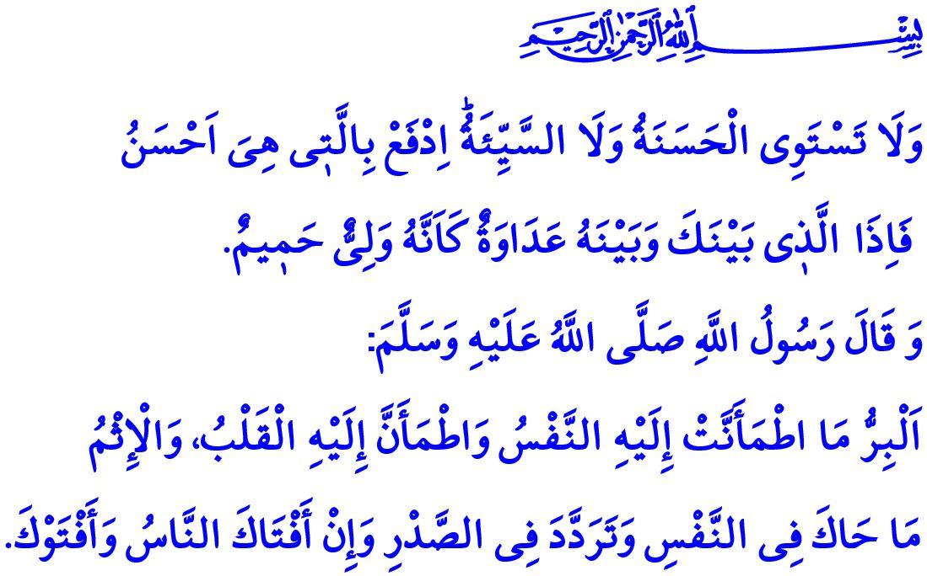
GOODNESS INCREASES WHEN SHARED
Dear Muslims!
Nine years had passed since the Prophet Muhammad’s (saw) Hijrah to Madinah. Islam was spreading in waves, and the souls thirsty of faith was flowing toward Madinah. Among those souls heading to Madinah al-Munawwarah to enter into Islam was a man named Vabisa. Having recited the Kalimah al-Shahadah and got the honor of becoming a Muslim, he asked the Prophet Muhammad (saw) about what the good and the evil meant. The Prophet Muhammad (saw) held his three fingers together, tapped on Vabisa’s chest, and said, “Goodness is the thing that brings your heart to peace and what you are comfortable with. Evil is the thing that makes you feel uneasy, doubtful, suspicious, and anxious even if people gave you a fatwa.”
Honorable Believers!
Goodness means to have faith in Allah, in the Last Day, in the angels, in the divine books, and in the prophets, as expressed by the Holy Qur’an, which is the guide of our lives. It means to ensure one’s faith is accompanied by good deeds. It means to spend from one’s loved properties for the close ones, for the orphan, for the poor, for those who were lost in a journey, and, in short, for all those in need. It means to perform prayer, to pay alms, and to keep a given promise. It means to show patience in straitened circumstances, in illness, and in wartime, and to be thankful to Allah in wealth and health.
Honorable Muslims!
Goodness is one’s most profitable gain and the most valuable inheritance in life. It means to give an ear to the voice of a compassionate soul, to be a brother for the orphan, the source of happiness for the poor, and the helpers for the refugees and the immigrants. It means to give a hand, and open one’s house and heart for the oppressed. It means to protect the environment and not even hurt an ant. It means to treat compassionately all created beings for the sake of the Creator. It means to share one’s food, pray, love, and sorrow.
Dear Muslims!
Nothing can and should surpass the approval of Allah (swt) in value for Muslims. They pursue goodness and good deeds without expecting to be appreciated by other people, and falling for arrogance, boastfulness, and pretentiousness. They seek out opportunities to be a source of goodness, motivated by the feelings of mercy and compassion as blessings by Allah (swt). To earn the approval of Allah (swt), they spend all the blessings entrusted to them by Him again in His cause.
They are aware that they can be considered good only when they spend what they love most in Allah’s cause. They fight against evil by inviting to good and by increasing goodness. They take the following commandment of Allah as their mantra for life, “And not equal are the good deed and the bad. Repel [evil] by that [deed] which is better; and thereupon the one whom between you and him is enmity [will become] as though he was a devoted friend.”
Honorable Believers!
It is deeply saddening that evil is all over the world today and those investing in it cause great sufferings for humanity. Muslims are exposed to oppression, pressure, and violence in the oppressed corners of the Islamic geography. Particularly, women and children who are squirming in despair, imprisoned, forced to migrate are breaking our hearts despite the fact that women are our mothers who teach us the unrequited good by stretching the wings of compassion upon us. They are our spouses who work for the proliferation of goodness in our homes, for the happiness and peace to take root. They are our daughters as the light of our eyes and our prayers for goodness in both worlds. To hurt them, to condemn them to a world devoid of compassion and justice, to make them victims and oppressed are both a grave sin.
Dear Believers!
Every good deed done, even if small, is precious. One can do many good deeds with one’s hand, tongue, asset, knowledge, and experience. Even if small as the size of a date palm, the Almighty Allah (swt)makes it larger as Mount Uhud, as long as humans favor the good and take the side of the good, endeavor to let the good prevail the world by standing against the evil, wars, poverty, and violence. In this respect, the Messenger of Allah (saw) says, “He who amongst you sees something abominable should modify it with the help of his hand; and if he has not strength enough to do it, then he should do it with his tongue, and if he has not strength enough to do it, (even) then he should (abhor it) from his heart, and that is the least of faith.”
Honorable Muslims!
Let us follow in the footsteps of the good, the betterment, the justice, and the compassion. Let us stand against the evil, the depravement, the oppression, the sedition, and the violence. It is the good that will change the world and save the future. Let us not forget that Allah (swt), the Lord of the Worlds, will certainly support those who endeavor to spread the good in the world, and will never leave them alone, nor unaided.

Darimi, Buyu, 2.
Baqarah, 2/177.
Fussilat, 41/34.
Muslim, Îman, 78. General Directorate of Religious Services

